**The Partograph as Modeled in Arden syntax for CDSS development**

# **Background**

The Partograph is a printed graphical record used to monitor and report the progress of labour during childbirth (Lavender & Bernitz, 2020). When applied correctly, the Partograph is a key tool in the intervention to identify and make decisions about complications that arise during child labour (Bernitz et al.). According to the WHO, the objective of the partograph was to guide midwives and physicians – attending to mothers giving birth – in making the decisions such as the need for augmented labour, artificial rupturing of membranes, and a caesarean section. Furthermore, the WHO, in their 2016 publication on guidelines for a positive pregnancy experience (WHO, 2016) recommended that foetal assessments guided with the use of ultrasound equipment and documented onto this partograph in a bid to reduce neonatal mortality by identifying complications such as distress.

Maternal mortality – as per publications cited by Ozimek (Ozimek & Kilpatrick, 2018) –varied between 12 deaths per 100,000 live births in industrialized nations, compared to 546 in sub-Saharan Africa and as many as 1100 in Sierra Leone alone in a 25-year range. In addition, neonatal mortality varied between 42.3 - 27.5 per 1000 live births. In sub-Saharan Africa alone and this within a 19-year range (Parmigiani & Bevilacqua).

According to a study by Negash and Alelgn et al published in 2021, proper partograph utilization was just over 50% in Ethiopia (Negash & Alelgn, 2022). Before that study, Tilahun et al, had found it to be below 50% (43%) with associated factors such as knowledge, education level, and a conducive obstetric facility in the same country. In Uganda, a study conducted to determine the level of Partograph completion and use by Mukisa, J et al published in 2019, found that documentation of age, gravidity, and parity had incompletion rates of 79.1, 52.7, and 3.2 percent respectively. Another study found that completion rates as per WHO standards were only at 4.2% in Uganda (Lugobe et al., 2019). This could indicate to the quality of care received by mothers giving birth is below the recommendations (WHO, 2016). The WHO has since revised the recommendations from the earlier partograph to the Labour Care guide that would improve the experience for women and their babies during childbirth. Consolidated from evidence-based clinical care, the new tool recommends practices that promote a positive childbirth experience (WHO, 2021).

The adoption and application of Clinical decision support systems amplify the quality of care by creating accountability systems with alerts and actions in managing complications during childbirth. Through constructing procedural and knowledge-based rules from the new WHO Labour care guide, and translating them into logical statements that generate alerts and post actions for obstetric caregivers during labour, a clinical decision support system influences the desired outcomes. This submission, therefore, illustrates the possibility of conversion of clinical guidelines into decision rules to support the progress of labour with the development of MLMs.

# **Key decisions made by a physician/Nurse during labour**

1. When to artificially rupture membranes and aid normal delivery.
2. When to assist the mother turn left.
3. When and why to carry out caesarian birth.
4. When to argument labour and relieve pain.
5. When to refer the woman from one facility to another.

By embedding the key decisions in several Medical logic modules, we illustrate that alerts and recommended actions invoked by the provided the arguments from variables about the woman in active labour have been captured by an EMR or directly entered into a communication portal (EMR interface) by the caregivers. We further demonstrate each with the decision tables that identify when to alert and recommended action to the caregivers during active labour. Point to note that under certain circumstances, several other decisions have to be made and recommended by the CDS and these have been listed in the decision tables. The corresponding alerts are also presented within the very decision table of a major action for the caregiver to act upon.

# **Decision 1: Augmentation Labour.**

During the active stages of labour when cervical dilation size is at 5cm and three contractions per 10 minutes, the expected progress is monitored where the membranes are intact and cervical dilation progress at 1cm per hour increase. However, conditions arise such as the membranes rupturing and cervical dilation not progressing 1cm per hour for 4 hours. In this moment, the health attendant to the woman should check for other conditions such as the amniotic fluid to check for meconium and test for protein in the urine to determine if there is a presence of pre-eclampsia. Therefore, documenting certain alerts and actions to assist the safe delivery of the baby are important in building decision rules. Converting these rules into Medical logic modules for decision support in the EMRs is key in improving the quality of care at birth.

## **Alerts and actions for Augmentation of labour.**

Conditions for augmenting labour:

Ruptured membranes – this is determined by the presence of meconium in the amniotic fluid and marked as B

Pre-eclampsia – a condition signified with protein in the urine.

Prolonged labour – when the labour has not progressed over a 4-hour meaning that no cervical dilation greater than 1cm per hour.

|  |  |  |
| --- | --- | --- |
| Decision | Alert | Actions |
| Augment Labour | Investigate / Do nothing | Check after 4 hours |
|  | Possible pre-eclampsia Detected | Recommend IV fluids, anti-convulsion medication such Magnesium sulfate |
|  | Ruptured membranes | Recommend Ampicillin IV 2g then 1 g every four hours |

## **Decision table for Labour augmentation.**



**The mlm code for labour augmentation.**

**maintenance:**

**title:** title;;

**mlmname:** AugmentLabour;;

**arden:** version 2.9;;

**version:** 0.1;;

**institution:** MHI2021;;

**author:** Group 4;;

**specialist:** Mark Outeke, Raphael Birenge, Stella Akidi;;

**date:** 2023-01-28;;

**validation:** testing;;

**library:**

**purpose:** Conditions to Augment labour provided the period is now 4 hours after start of labour

this might be provided by the system and no need to be captured again.;;

**explanation:** Augmenting labour is a decision made if there is a presence of

pre-eclampsia and prolonged labour of more than 4 hours without improved cervical dilatation of 1cm every one hour.;;

**keywords:** ;;

**citations:** ;;

**links:** ;;

**knowledge:**

**type:** **data_driven**;;

**data:**

//declare cutoffs for measuring high blood pressure and labour period presence needed for augmentation of labour

**let** Ucutoff_SYsBPH **be** 140;

**let** Ucutoff_DiaBPH **be** 90;

**let** Lcutoff_SYsBPH **be** 80;

**let** Lcutoff_DiaBPH **be** 60;

LabourPeriod := 4 **hours**;

msg:=**null**;

intervention:= **null**;

(Amniotic_Fluid, SYsBPH, DiasBPH, Urine, DilationSize) := **argument**;

**priority:** ;;

**evoke:** ;;

**logic:**

**if** Amniotic_Fluid **is** **not** **equal** "B" **and**

Ucutoff_SYsBPH < SYsBPH **and** Ucutoff_DiaBPH < DiasBPH **and**

Urine **is** **not** **equal** "P++" **and**

DilationSize > 5 **and**

LabourPeriod **is** **present**

**then**

**elseif** Amniotic_Fluid **is** **not** **equal** "B" **and**

Ucutoff_SYsBPH < SYsBPH **and** Ucutoff_DiaBPH < DiasBPH **and**

Urine **is** **not** **equal** "P++" **and**

DilationSize < 5 **and**

LabourPeriod **is** **present**

**then**

intevention := **false**;

msg:= "Do nothing";

**endif**;

**if** Amniotic_Fluid **is** **not** **equal** "B" **and**

Ucutoff_SYsBPH > SYsBPH **and** Ucutoff_DiaBPH > DiasBPH

**and** Urine **is** **not** **equal** "P++" **and**

DilationSize < 5 **and**

LabourPeriod **is** **present**

**then**

**if** Amniotic_Fluid **is** **not** **equal** "B" **and**

Ucutoff_SYsBPH > SYsBPH **and** Ucutoff_DiaBPH > DiasBPH

**and** Urine **is** **equal** "p++" **and**

DilationSize > 5 **and**

LabourPeriod **is** **present**

**then**

msg := "Possible pre-eclampsia detected";

**elseif** Amniotic_Fluid **is** **equal** "B" **and**

Ucutoff_SYsBPH > SYsBPH **and** Ucutoff_DiaBPH > DiasBPH

**and** Urine **is** **equal** "P++" **and**

DilationSize < 5 **and**

LabourPeriod **is** **present**

**then**

intervention := **true**;

msg := "Possible pre-eclampsia detected, Recommend IV fluids and Magnesium Sulfate.";

**endif**;

**endif**;

**if** Amniotic_Fluid = "B" **and**

Ucutoff_SYsBPH < SYsBPH **and** Ucutoff_DiaBPH < DiasBPH

**and** Urine = "P++" **and**

DilationSize < 5 **and**

LabourPeriod **is** **present**

**then**

intervention :=**true**;

msg := "Recommended Augmentation of labour with Oxytocin IV at 15 mu per minute";

**endif**;

**conclude** **true**;

;;

**action:**

**return** msg;

;;

**urgency:** ;;

**end:**

## **The JSON File of arguments**

**{ "type": "list",**

**"primaryTime": "2012-04-23T18:25:43.511Z",**

**"applicability": 1,**

**"values": [**

**{**

**"type": "string",**

**"primaryTime": "2012-04-23T18:25:43.511Z",**

**"applicability": 1,**

**"value": "B"**

**},**

**{**

**"type": "number",**

**"primaryTime": "2012-04-23T18:25:43.511Z",**

**"applicability": 1,**

**"value": 170**

**},**

**{**

**"type": "number",**

**"primaryTime": "2012-04-23T18:25:43.511Z",**

**"applicability": 1,**

**"value": 100**

**},**

**{**

**"type": "string",**

**"primaryTime": "2012-04-23T18:25:43.511Z",**

**"applicability": 1,**

**"value": "P++"**

**},**

**{**

**"type": "number",**

**"primaryTime": "2012-04-23T18:25:43.511Z",**

**"applicability": 1,**

**"value": "4"**

**}**

**]**

**}**

## **The Output for labour augmentation.**

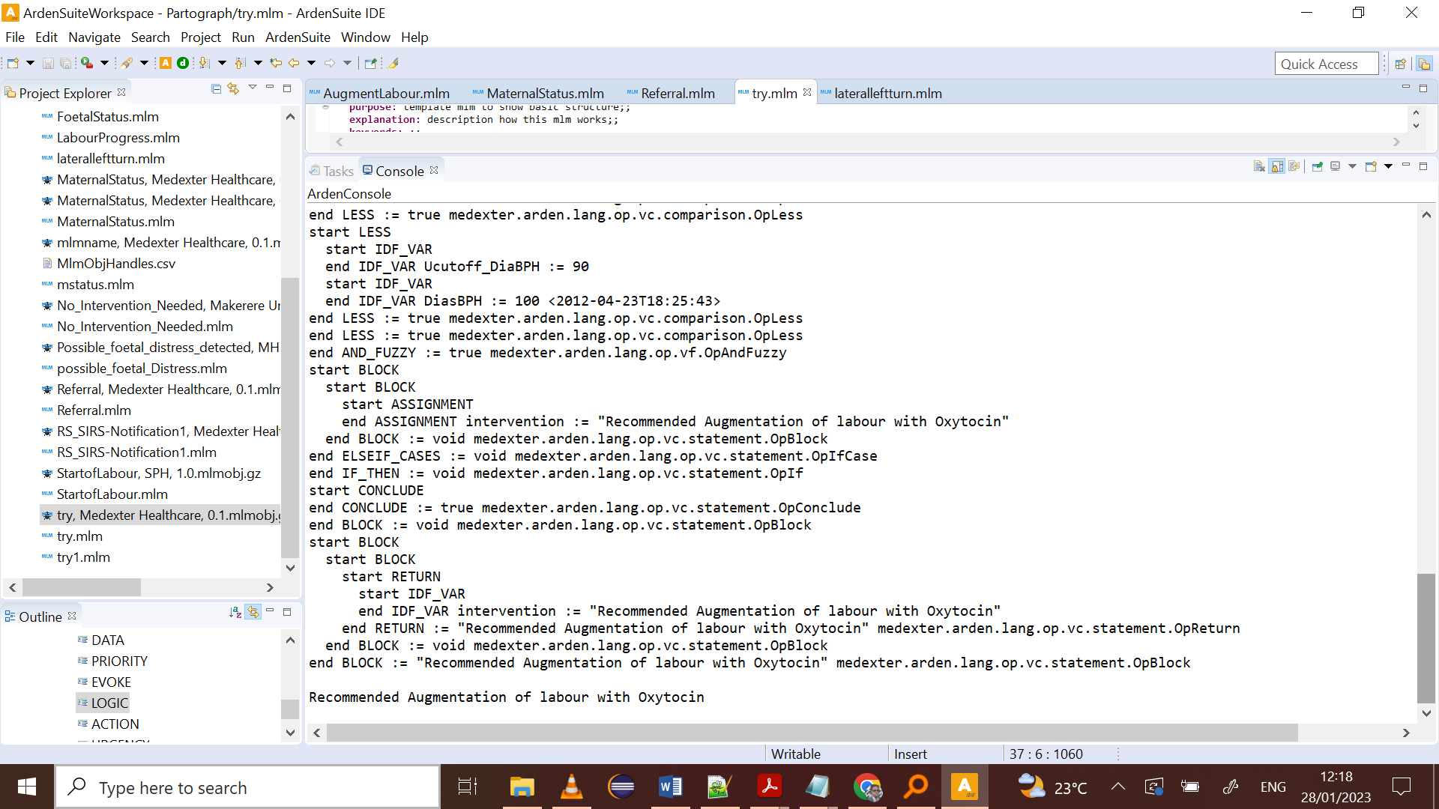

# **Decision 2: Caesarean Delivery.**

Complications during labour arise from several conditions and one key decision is when to carry out an emergency caesarean section delivery. When the maternal heart rate is out of range and there is presence of Hypotension, the fetus is in distress. In addition, when the fetus in any occiput transverse position (marked as “T”) and uterine ruptures present and identified by bloody meconium with the former conditions, then an emergency caesarean section is recommended to save the mother and baby.

**Alerts and Actions for Caesarean Delivery.**

Conditions as mentioned above tabled below.

|  |  |  |
| --- | --- | --- |
| Decision | Alert | Actions |
| Caesarean section delivery | Hypotension Detected | Administer Vasopressors (Phenylephrine)to elevate the Blood pressure to acceptable level. |
|  | Hypotension, Transverse position, Obstructed labour, Fetal Distress | Emergency Caesarean section delivery |
| Transverse fetal position | External version between two contractions as early as possible |
| Hypertension Detected | Administer Hydralazine to woman at 5-10mg / 15-20 minutes |
| Fetal Distress Detected | Assist woman turn left or Walk around |
| Possible hemorrhagic shock | Recommend Blood transfusion to the mother, Oxygen administration |

**Decision table for Caesarean Delivery.**



**The mlm code Caesarean Delivery.**

**maintenance:**

**title:** title;;

**mlmname:** CaesereanSection;;

**arden:** version 2.9;;

**version:** 0.1;;

**institution:** SPH MHI2021;;

**author:** Group4;;

**specialist:** Mark Outeke, Raphael Birenge, Stella Akidi;;

**date:** 2023-01-28;;

**validation:** testing;;

**library:**

**purpose:** This MLM is for making the decision necessary for recommending ;;

**explanation:** The mlm takes arguments such as the measure of the woman’s blood pressure, the fetal position, and determines if the

woamn has hypotension with uterine ruptures all which are necessary for a caesarean section delivery;;

**keywords:** ;;

**citations:** ;;

**links:** ;;

**knowledge:**

**type:** **data_driven**;;

**data:**

**let** Ucutoff_SYsBPH **be** 140;

**let** Ucutoff_DiaBPH **be** 90;

**let** Lcutoff_SYsBPH **be** 80;

**let** Lcutoff_DiaBPH **be** 60;

uterineRupture:=**false**;

msg:=**null**;

intervention:= **null**;

(MHR, SYsBPH, DiasBPH, FetalPosition ) := **argument**;

Hypotension:= SYsBPH <90 **and** DiasBPH < 60;

;;

**priority:** ;;

**evoke:** ;;

**logic:**

**if** MHR < 160 **and**

Hypotension **is** **not** **present** **and**

FetalPosition **is** **not** **equal** "T" **and** uterineRpture = **false** **then**

intervention := **false**;

msg:= "Do nothing";

**elseif**

MHR < 160 **and**

Hypotension **is** **present** **and**

FetalPosition **is** **not** **equal** "T" **and** uterineRpture = **false** **then**

intervention:=**true**;

msg := "Hypotension Detected";

**endif**;

**if** MHR < 160 **and**

Hypotension **is** **present** **and**

FetalPosition **is** **equal** "T" **and** uterineRpture = **false** **then**

intervention := **false**;

msg:="Recommend IV fluids, Vertical Walking of woman. If sever then consider Caesarean Section ";

**elseif**

MHR < 160 **and**

Hypotension **is** **present** **and**

FetalPosition **is** **equal** "T" **and** uterineRpture = **false** **then**

intervention := **false**;

msg:="Recommended vigorous Resuscitation, and Emergency Caesarean Section Delivery . ";

**endif**;

**if** MHR > 160 **and**

Hypotension **is** **present** **and**

FetalPosition **is** **equal** "T" **and**

uterineRupture **is** **present** **then**

intervention := **true**;

msg := "Recommend immediate Caesarean Section Delivery.";

**endif**;

**conclude** **true**;

;;

**action:**

**return** msg;

;;

**urgency:** ;;

**end:**

## **The JSON Arguments.**

**{**

**"type": "list",**

**"primaryTime": "2012-04-23T18:25:43.511Z",**

**"applicability": 1,**

**"values": [**

**{**

**"type": "number",**

**"primaryTime": "2012-04-23T18:25:43.511Z",**

**"applicability": 1,**

**"value": 170**

**},**

**{**

**"type": "number",**

**"primaryTime": "2012-04-23T18:25:43.511Z",**

**"applicability": 1,**

**"value": 80**

**},**

**{**

**"type": "number",**

**"primaryTime": "2012-04-23T18:25:43.511Z",**

**"applicability": 1,**

**"value": 57**

**},**

**{**

**"type": "string",**

**"primaryTime": "2012-04-23T18:25:43.511Z",**

**"applicability": 1,**

**"value": "T"**

**}]**

**}**

## **The Output for Caesarean Delivery**

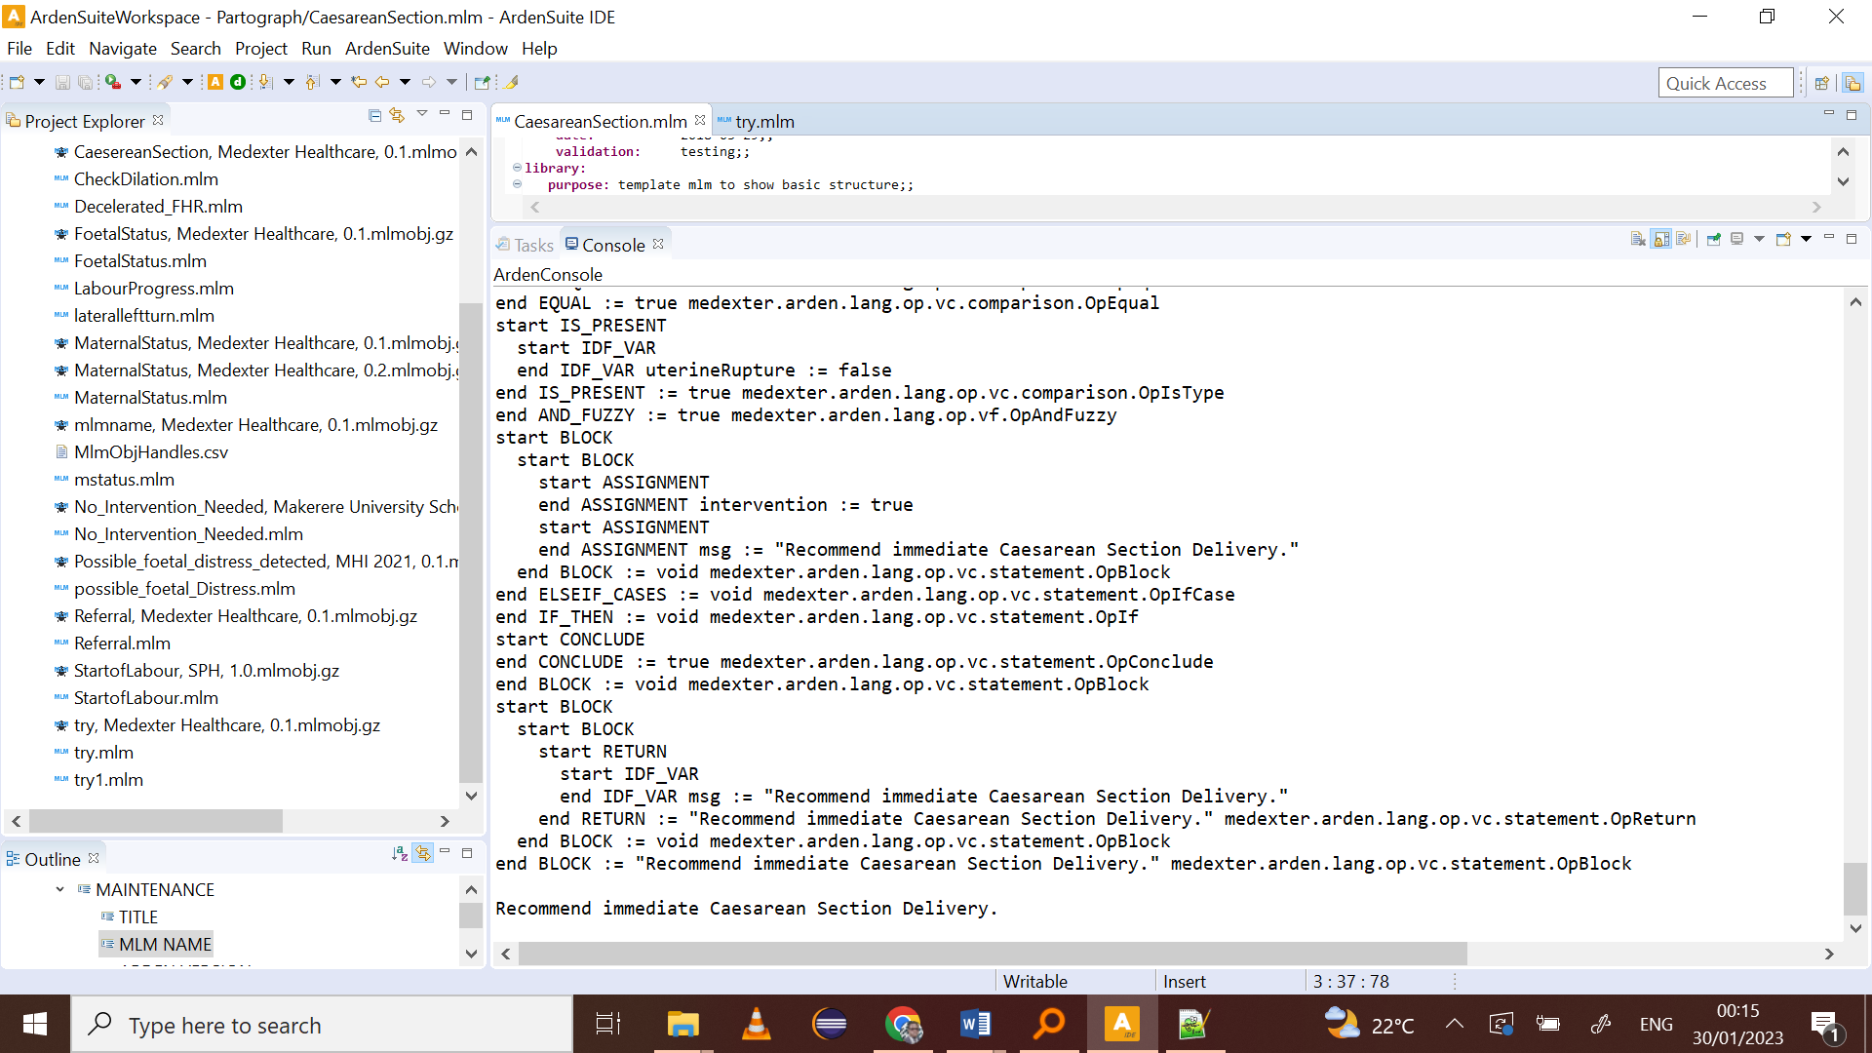

# **Decision 3: Artificial Rupturing of Membranes.**

For Artificial Rupturing of Membranes to occur certain conditions must have prevailed over time during the active phase of labour. The Amniotic Fluid recorded to have Meconium labeled as “B”, Fetal position; “T”, Presence of Cervical dilatation of more than 5 cm, and Contraction period per 10 minutes are the conditions necessary before artificial rupturing of membranes. This is done if the membranes are still intact and yet presence of bloody amniotic fluid as evident. The decision is made to augment labour and have the delivery early and where not possible through normal birth process, augmentation and caesarean section have to be urgently done.

## **Alerts and actions for artificial rupturing of membranes.**

|  |  |  |
| --- | --- | --- |
| Decision | Alert | Actions |
| Artificial Rupture of Membranes | Transverse fetal position | External version between two contractions as early as possible |
|  | Contractions < 5 per 10 minutes Insufficient contractions Detected | Recommend Augmentation of labour |
|  | Obstructed labour | Recommend Augmentation of labour |
|  | Placenta abruption when Dilatation is less than 5cm after 4 hours | Artificial Rupturing of membranes recommended |

## **Decision table Artificial Rupturing of Membranes.**



## **The mlm code Artificial Rupturing of Membranes**

**maintenance:**

**title:** title;;

**mlmname:** ArticialRuptureMem;;

**arden:** version 2.9;;

**version:** 0.1;;

**institution:** SPH MHI2021;;

**author:** Group4;;

**specialist:** Mark Outeke, Raphael Birenge, Stella Akidi;;

**date:** 2023-01-28;;

**validation:** testing;;

**library:**

**purpose:** To alert and call action for Artificially rupturing membranes of the

woman to aid normal , vacuum and augmented labour incases of obstructed labour among other complications ;;

**explanation:** The MLM takes arguments from ;;

**keywords:** ;;

**citations:** ;;

**links:** ;;

**knowledge:**

**type:** **data_driven**;;

**data:**

msg:=**null**;

intervention:= **null**;

(Amniotic_Fluid, FetalPosition, DilatationSize,ContractionsPrd) := **argument**;

;;

**priority:** ;;

**evoke:** ;;

**logic:**

**if** Amniotic_Fluid **is** **not** **equal** "B" **and**

FetalPosition **is** **not** **equal** "T" **and**

DilatationSize > 5 **and**

ContractionsPrd > 5 **then**

**elseif**

Amniotic_Fluid **is** **equal** "B" **and**

FetalPosition **is** **equal** "T" **and**

DilatationSize > 5 **and**

ContractionsPrd < 5 **then**

intervention := **false**;

msg := "Investigate after 4 hours. ";

**endif**;

**if**

Amniotic_Fluid **is** **not** **equal** "B" **and**

FetalPosition **is** **equal** "T" **and**

DilatationSize < 5 **and**

ContractionsPrd > 5 **then**

**elseif**

Amniotic_Fluid **is** **not** **equal** "B" **and**

FetalPosition **is** **equal** "T" **and**

DilatationSize < 5 **and**

ContractionsPrd < 5 **then**

intervention := **true**;

msg := "Obstructed Labour Detected, Recommend Vacuum Delivery ";

**endif**;

**if** Amniotic_Fluid **is** **equal** "B" **and**

FetalPosition **is** **equal** "T" **and**

DilatationSize < 5 **and**

ContractionsPrd > 5 **then**

intervention := **true**;

msg:= "Placenta Prevai Detected : Recommended Artificial Rupturing of membranes ";

**endif**;

**conclude** **true**;

;;

**action:**

**return** msg;

;;

**urgency:** ;;

**end:**

## **THE JSON File of arguments**

{

"type": "list",

"primaryTime": "2012-04-23T18:25:43.511Z",

"applicability": 1,

"values": [

{

"type": "string",

"primaryTime": "2012-04-23T18:25:43.511Z",

"applicability": 1,

"value": "B"

},

{

"type": "string",

"primaryTime": "2012-04-23T18:25:43.511Z",

"applicability": 1,

"value": "T"

},

{

"type": "number",

"primaryTime": "2012-04-23T18:25:43.511Z",

"applicability": 1,

"value": 4

},

{

"type": "number",

"primaryTime": "2012-04-23T18:25:43.511Z",

"applicability": 1,

"value": 6

}

]

}

## **The Output Artificial Rupturing of Membranes**.

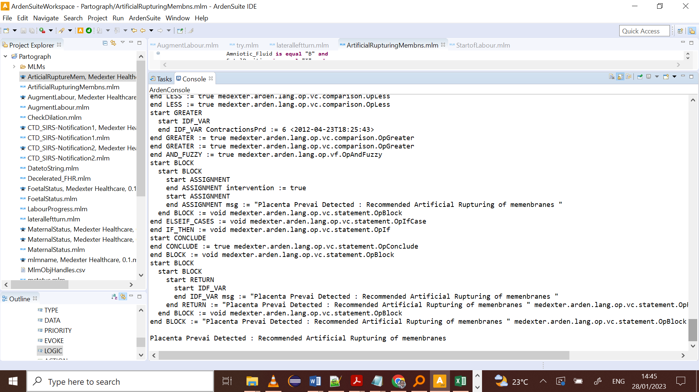

# **Decision 4: Lateral left turn for Woman.**

There are conditions that require for the Lateral left turn for Woman to occur during the active phase of labour. These are the fetal heart rate out of acceptable range during the absence of contractions and presence of deceleration of the fetal heart rate after regular contractions in every ten (10) minutes. This complication can arise through various indicators however, the one that takes precedence as per the WHO labour care guide are the mentioned two. We describe these in the section of the decision table which will be followed with the code and console outputs of the debug process with the a .json file for input arguments to the mlm.

**Alerts and Actions for Lateral Left turn.**

|  |  |  |
| --- | --- | --- |
| Decision | Alert | Actions |
| Lateral Left turn of woman | Fetal Distress when heart rate is high | Assist woman gently turn to her left side. |
|  | Decelerated Fetal heart Rate, Fetal distress Detected | Assist woman gently turn to her left side. |

## **Decision table Lateral left turn for Woman.**



## **The mlm code Lateral left turn for Woman.**

maintenance:

title: title;;

mlmname: Lateralturnleft;;

arden: version 2.9;;

version: 0.1;;

institution: SPH MHI2021;;

author: Group4;;

specialist: Mark Outeke, Raphael Birenge, Stella Akidi;;

date: 2023-01-28;;

validation: testing;;

library:

purpose: To Demonstrate the decision for lateral left turn;;

explanation: MLM takes the simple arguments of the fetal Heart rate and

wether it decelerates over time after during very contraction period.;;

keywords: ;;

citations: ;;

links: ;;

knowledge:

type: data_driven;;

data:

allvalues:= ARGUMENT;

msg:=null;

intervention:= null;

(FHR, DeceleratedFHR):= argument;

let ucutoff_FHR be 160;

let lcutoff_FHR be 110;

;;

priority: ;;

evoke: ;;

logic:

if FHR >= ucutoff_FHR and DeceleratedFHR is not equal "L" then

elseif FHR < lcutoff_FHR and Deceleration is not equal "L" then

intervention:=false;

msg:="Alert: Possible Fetal Distress Detected";

endif;

if FHR < lcutoff_FHR and DeceleratedFHR is equal "L" then

elseif FHR >= ucutoff_FHR and DeceleratedFHR is equal "L" then

intervention:=true;

msg:= "Fetal Distress detected, Assist Woman to turn left";

endif;

conclude true;

;;

action:

return msg;

;;

urgency: ;;

end:

**The JSON file with arguments.**

{

"type": "list",

"primaryTime": "2012-04-23T18:25:43.511Z",

"applicability": 1,

"values": [

{

"type": "number",

"primaryTime": "2012-04-23T18:25:43.511Z",

"applicability": 1,

"value": 180

},

{

"type": "string",

"primaryTime": "2012-04-23T18:25:43.511Z",

"applicability": 1,

"value": "L"

}

]

}

## **The Output Lateral left turn for Woman**

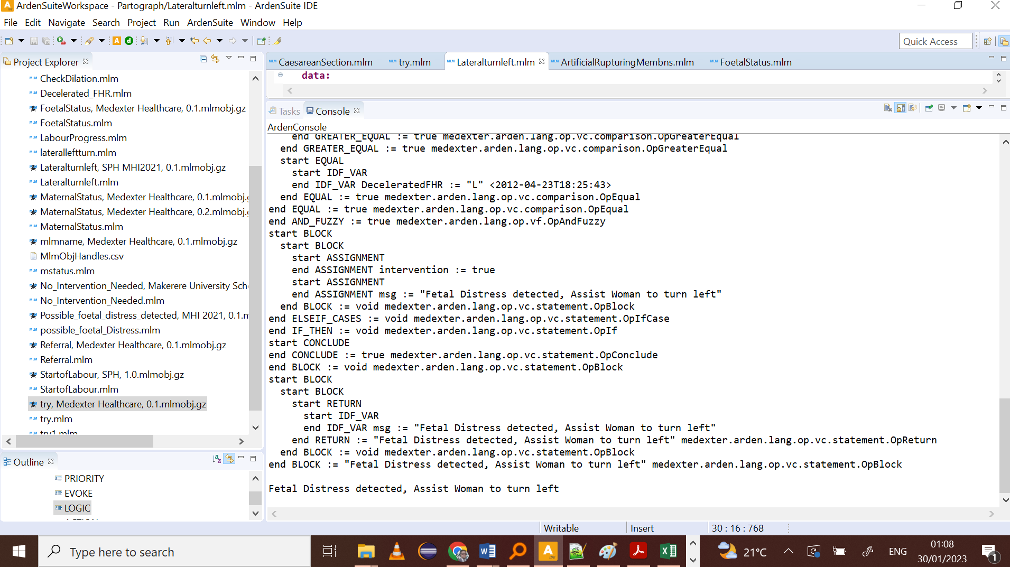

# **Decision 5: Referrals to other facilities.**

In low-income countries such as Uganda, maternal and antenatal services are offered by different levels of healthcare. For a woman to be referred upwards from a low-level facility, certain conditions must be assessed before they are referred to a comprehensive facility. Basics[emergency obstetric and newborn care (BEmONC)](https://bmcpregnancychildbirth.biomedcentral.com/articles/10.1186/s12884-018-1751-z) services are offered with a range of services however; do not perform caesarean sections and Blood transfusion, but Comprehensive emergency obstetric and newborn care (CEmONC)

## **Alerts and Actions for Referrals.**

|  |  |  |
| --- | --- | --- |
| Decision | Alert | Actions |
| Referrals | Possible Placenta Abrutio | Refer Woman to CEmONC facility for Caesarean Section Delivery |
|  | Hypotension Detected | Recommend Vasopressor IV |
|  | Possible hemorrhagic shock | Refer Woman to CEmONC facility for Caesarean Section Delivery |
|  | Uterine Rupture Detected | Refer Woman to CEmONC facility for Caesarean Section Delivery |
|  | Maternal Heart Rate Out of range | Administer Hydralazine |
|  | Transverse Fetal Position | External Version, if fail Refer Woman to CEmONC facility for Caesarean Section Delivery |
|  | Possible Fetal Tachycardia | Recommend administration of Flecainide Acetate |

## **The Decision table for conditions to make the referral to a CEmONC facility**



**The mlm code for referral to a CEmONC facility.**

**Maintenance:**

**title:** title;;

**mlmname:** Referral;;

**arden:** version 2.9;;

**version:** 0.1;;

**institution:** MHI2021;;

**author:** Group 4;;

**specialist:** Mark Outeke, Raphael Birenge, Stella Akidi;;

**date:** 2023-01-28;;

**validation:** testing;;

**library:**

**purpose:** Demonstrate the requirements for referring a Woman from one facility to another;;

**explanation:** The MLM gets attributes necessary for the condition of transfer and creates a reminder for when the woman should be transferred.

Conditions include whether the woman need an Emergency Caesarean Section or Blood transfusion. ;;

**keywords:** ;;

**citations:** ;;

**links:** ;;

**knowledge:**

**type:** **data_driven**;;

**data:**

allvalues:= **argument**;

**let** Uppercutoff_SYsBPH **be** 140;

**let** Uppercutoff_DiaBPH **be** 90;

**let** Lowercutoff_SYsBPH **be** 80;

**let** Lowercutoff_DiaBPH **be** 60;

(Amniotic_Fluid,FetalPosition, SYsBPH, DiasBPH, MHR, Facility_type) := **Argument**;

uterineRupture:=**false**;

msg:=**null**;

intervention:= **null**;

Hypotension := SYsBPH <90 **and** DiasBPH < 60;

;;

**priority:** ;;

**evoke:** ;;

**logic:**

**if** Facility_type **is** **equal** "BEmONC" **and**

MHR < 160 **and**

Amniotic_Fluid **is** **not** **equal** "B" **and**

Hypotension **is** **not** **present** **and**

FetalPosition **is** **not** **equal** "T" **and**

uterineRupture **is** **not** **present** **then**

intervention := **false**;

**elseif** Facility_type **is** **equal** "BEmONC" **and**

MHR < 160 **and**

Amniotic_Fluid **is** **equal** "B" **and**

Hypotension **is** **not** **present** **and**

FetalPosition **is** **not** **equal** "T" **and**

uterineRupture **is** **not** **present** **then**

intervention := **true**;

msg:= "Possible placenta Abruption, Refer Woman to CEmONC facility for Caesarean Section Delivery.";

**elseif** Facility_type **is** **equal** "BEmONC" **and**

MHR < 160 **and**

Amniotic_Fluid **is** **not** **equal** "B" **and**

Hypotension **is** **not** **present** **and**

FetalPosition **is** **equal** "T" **and**

uterineRupture **is** **not** **present** **then**

intervention := **true**;

msg:= "Occiput Tranverse Detected , Conduct External Version after contarctions,

if fail refer to CEmONC facility for further management";

**elseif** Facility_type **is** **equal** "BEmONC" **and**

MHR > 160 **and**

Amniotic_Fluid **is** **not** **equal** "B" **and**

Hypotension **is** **present** **and**

FetalPosition **is** **not** **equal** "T" **and**

uterineRupture **is** **not** **present** **then**

intervention := **true**;

msg:= "Hypotension present, Possible hemorrhagic shock, Recommend Vassopessor adminstration.

Refer Woman to CEmONC facility for further management";

**elseif** Facility_type **is** **equal** "BEmONC" **and**

MHR > 160 **and**

Amniotic_Fluid **is** **not** **equal** "B" **and**

Hypotension **is** **not** **present** **and**

FetalPosition **is** **not** **equal** "T" **and**

uterineRupture **is** **present** **then**

intervention := **true**;

msg:= "Uterine Rupture Detected, Refer Woman to CEmONC facility for further management";

**elseif** Facility_type **is** **equal** "BEmONC" **and**

MHR > 160 **and**

Amniotic_Fluid **is** **equal** "B" **and**

Hypotension **is** **not** **present** **and**

FetalPosition **is** **not** **equal** "T" **and**

uterineRupture **is** **not** **present** **then**

intervention := **true**;

msg:= "Possible fetal Tachycardia, Administer Flecainide Acetate";

**elseif** Facility_type **is** **equal** "BEmONC" **and**

MHR > 160 **and**

Amniotic_Fluid **is** **equal** "B" **and**

Hypotension **is** **present** **and**

FetalPosition **is** **not** **equal** "T" **and**

uterineRupture **is** **not** **present** **then**

intervention := **true**;

msg:= "Refer Woman to CEmONC facility for further management";

**endif**;

**if** Facility_type **is** **equal** "BEmONC" **and**

MHR > 160 **and**

Amniotic_Fluid **is** **equal** "B" **and**

Hypotension **is** **present** **and**

FetalPosition **is** **equal** "T" **and**

uterineRupture **is** **present** **then**

intervention := **true**;

msg:= "Refer Woman to CEmONC facility for further management";

**endif**;

**CONCLUDE** **TRUE**;

;;

**action:**

**return** msg;

;;

**End:**

## **The JSON file of arguments**

{

"type": "list",

"primaryTime": "2012-04-23T18:25:43.511Z",

"applicability": 1,

"values": [

{

"type": "string",

"primaryTime": "2012-04-23T18:25:43.511Z",

"applicability": 1,

"value": "B"

},

{

"type": "string",

"primaryTime": "2012-04-23T18:25:43.511Z",

"applicability": 1,

"value": "T"

},

{

"type": "number",

"primaryTime": "2012-04-23T18:25:43.511Z",

"applicability": 1,

"value": 70

},

{

"type": "number",

"primaryTime": "2012-04-23T18:25:43.511Z",

"applicability": 1,

"value": 50

},

{

"type": "number",

"primaryTime": "2012-04-23T18:25:43.511Z",

"applicability": 1,

"value": "170"

},

{

"type": "string",

"primaryTime": "2012-04-23T18:25:43.511Z",

"applicability": 1,

"value": "BEmONC"

}

]

}

**The output for referral to a CEmONC facility.** 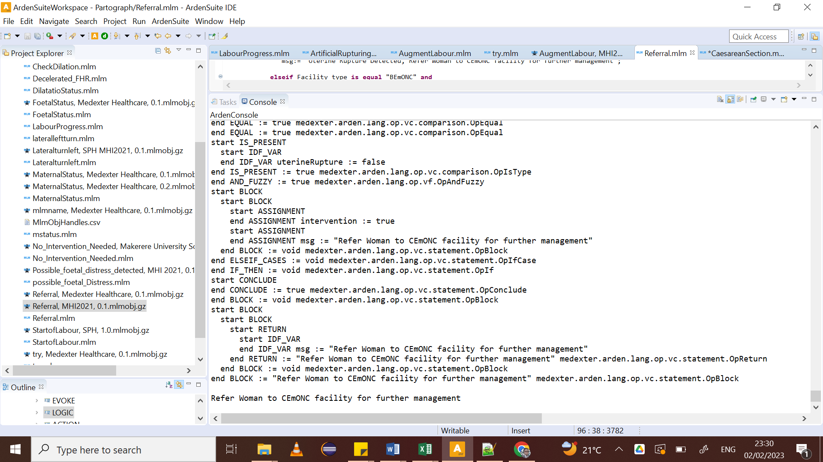

## **Limitations of this work.**

It is important to understand that there is several combinations of the conditions during active labour in the scope of our work. The second stage of labour also has similar activities that are also in our work. However, because of the level of experience and time allocation, we were not able to model from a working database. Options to read arguments directly from a working EMR are available and one can setup their own environment to respond to the MLMs. We have not demonstrated that functionality in this work.

## **Recommendations.**

Medical Logic modules are important in delivering decisions support reminders to healthcare givers. A key caution is in avoiding the delivery of multiple alerts for the same condition and therefore, careful thought process is required and must involve the healthcare givers in the development process. MLMs are powerful enough to influence the quality of healthcare, both positively and negatively. Therefore, continuous knowledge generation, update and use has to consider the cost associated in this sustainability requirement.

# **References.**

Bernitz, S., Dalbye, R., Zhang, J., Eggebø, T. M., Frøslie, K. F., Olsen, I. C., . . . Øian, P. The frequency of intrapartum caesarean section use with the WHO partograph versus Zhang's guideline in the Labour Progression Study (LaPS): a multicentre, cluster-randomised controlled trial. (1474-547X (Electronic)).

Lavender, T., & Bernitz, S. (2020). Use of the partograph - Current thinking. *Best Practice & Research Clinical Obstetrics & Gynaecology, 67*, 33-43. doi:<https://doi.org/10.1016/j.bpobgyn.2020.03.010>

Lugobe, H. M., Kanyesigye, H., Mpiima, D., Ssemujju, A., Masinda, A., Mulisya, O., . . . Mugyenyi, G. (2019). Older age and higher parity are associated with nonuse of the partograph at Mbarara Regional Referral Hospital, Uganda. (1879-3479 (Electronic)).

Negash, B. T., & Alelgn, Y. (2022). Proper partograph utilization among skilled birth attendants in Hawassa city public health facilities, Sidama region, Ethiopia, in 2021. (1472-6874 (Electronic)).

Ozimek, J. A., & Kilpatrick, S. J. (2018). Maternal Mortality in the Twenty-First Century. *Obstetrics and Gynecology Clinics of North America, 45*(2), 175-186. doi:<https://doi.org/10.1016/j.ogc.2018.01.004>

Parmigiani, S., & Bevilacqua, G. Can we reduce worldwide neonatal mortality? (2531-6745 (Electronic)).

WHO. (2016). WHO recommendations on antenatal care for a positive pregnancy experience. Retrieved from <https://www.who.int/publications/i/item/9789241549912>

WHO. (2021). WHO labour care guide: user’s manual. Retrieved from <https://www.who.int/publications/i/item/9789240017566>